
Golden Thread: Belonging
Physical Education – Unit 1 – Hockey
Autumn 1
Year 6
Working together to be the best that we can be
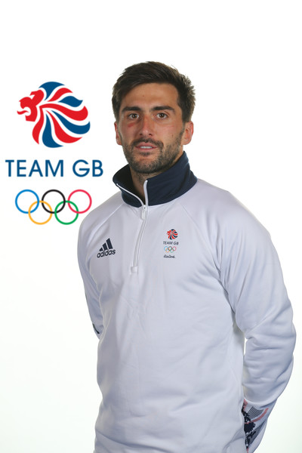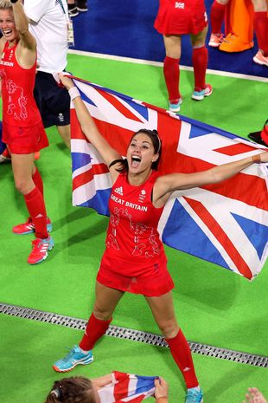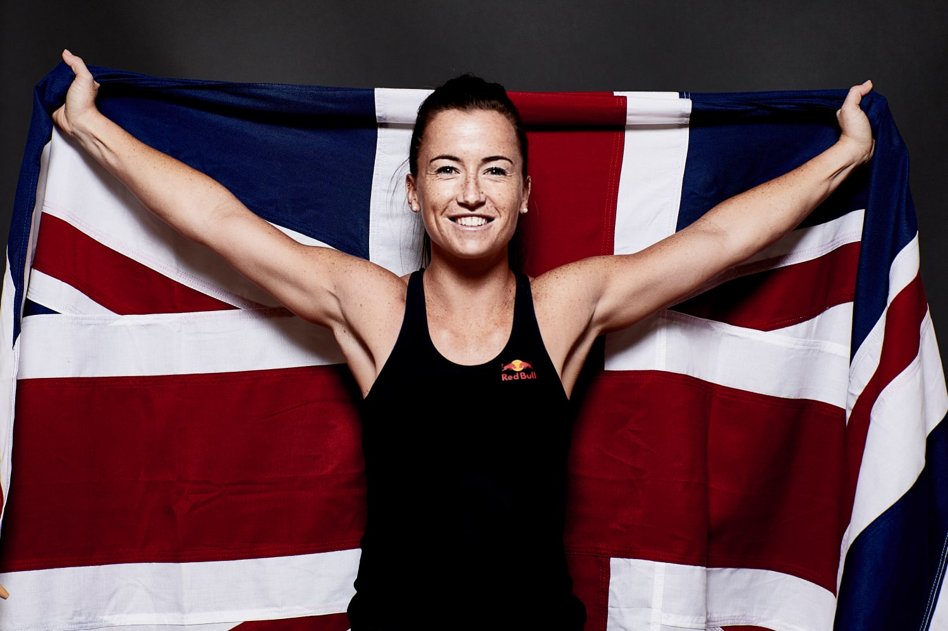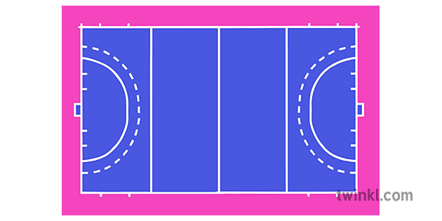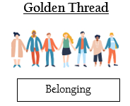
Key Vocabulary:
Power, distance, perform, consistent, fair play, tackle, covering, supporting, control, defend, attack, dribble, pass, push, tactics, compete, collaborate, score, shoot, positions, use space.

Adam Dixon – Team GB Captain
Sam Quek – Former Team GB Player and TV Pesonality
Maddie Hinch – Team GB Goal Keeper
Field Hockey Pitch

New skills:
Shooting at Close Range, Indian Dribble, Long Corner, Goal Side Marking, Banana Run and Match Play

