
Golden Thread: Belonging
Physical Education – Unit 1 – Tag Rugby
Autumn 1
Year 5
Working together to be the best that we can be
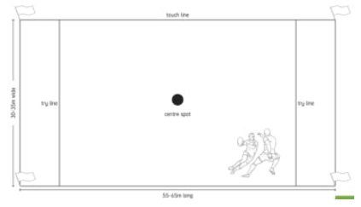
Key Vocabulary:
Tagging, opposition, contest, possession, pressure, support, pop pass, turn over, lose pass, W grip, offence, formation.

Maro Itoje – England Player Zoe Aldcroft – England Player
Tag Rugby Pitch

New Skills:
Defensive positions, how to tag an attacker, running and passing accurately, pop passes, magic diamond formation and match play.

