
Golden Thread: Sustainability/Belonging
Geography – Unit 1 – Weather and fieldwork skills
Autumn 1
Year 1
Working together to be the best that we can be
Weather
The Seasons
There are 4 seasons each year:
Spring Autumn

Summer Winter

Types of weather - What types of weather do you know?

Fieldwork Skills

Talking Points
What are the four seasons?
What is weather?
How do we make decisions?
What questions can we ask to help us make decisions?

To help us make decisions, we need to ask the right questions.
If you are growing a plant, you will need to ask the right questions so that the plant can grow.
Example: What weather conditions helps the plant to grow?
Here are the key things you need to ask:

Decision-making cycle

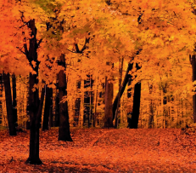
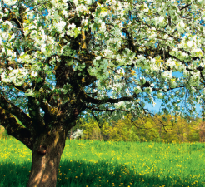
The weather begins to get cooler.
Months: September, October, November
The weather begins to get warmer.
Months: March, April, May

Key vocabulary
Climate - what the weather is usually like, e.g. it is usually hot in summer, cold in winter
Criteria - rules for deciding something
Data - facts collected together
Decision - what to do
Effect - a change to something
Record - write down information
Seasons - four parts of the year that, in the UK, have different weather
Temperature - how hot or cold something is
Thermometer - something used to measure temperature
Weather - what it is like outside today, e.g. is it raining or sunny?







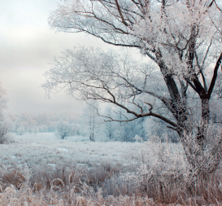

The weather is warm and we have more daylight.
Months: June, July, August
The weather is cold and we get frost and snow.
Months: December, January, February

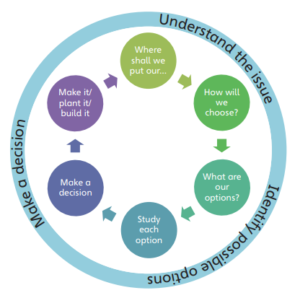
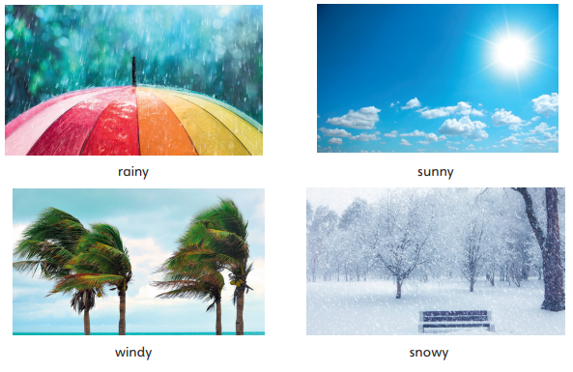
The weather changes as the seasons change. It’s warmer in Summer and colder in Winter.
The weather can change daily. One day it can rain and the next day it can be sunny. The weather can also change during a day.

