
Golden Thread: Belonging
English – Unit 1: What makes a writer?
Autumn 1
Year 2
Working together to be the best that we can be

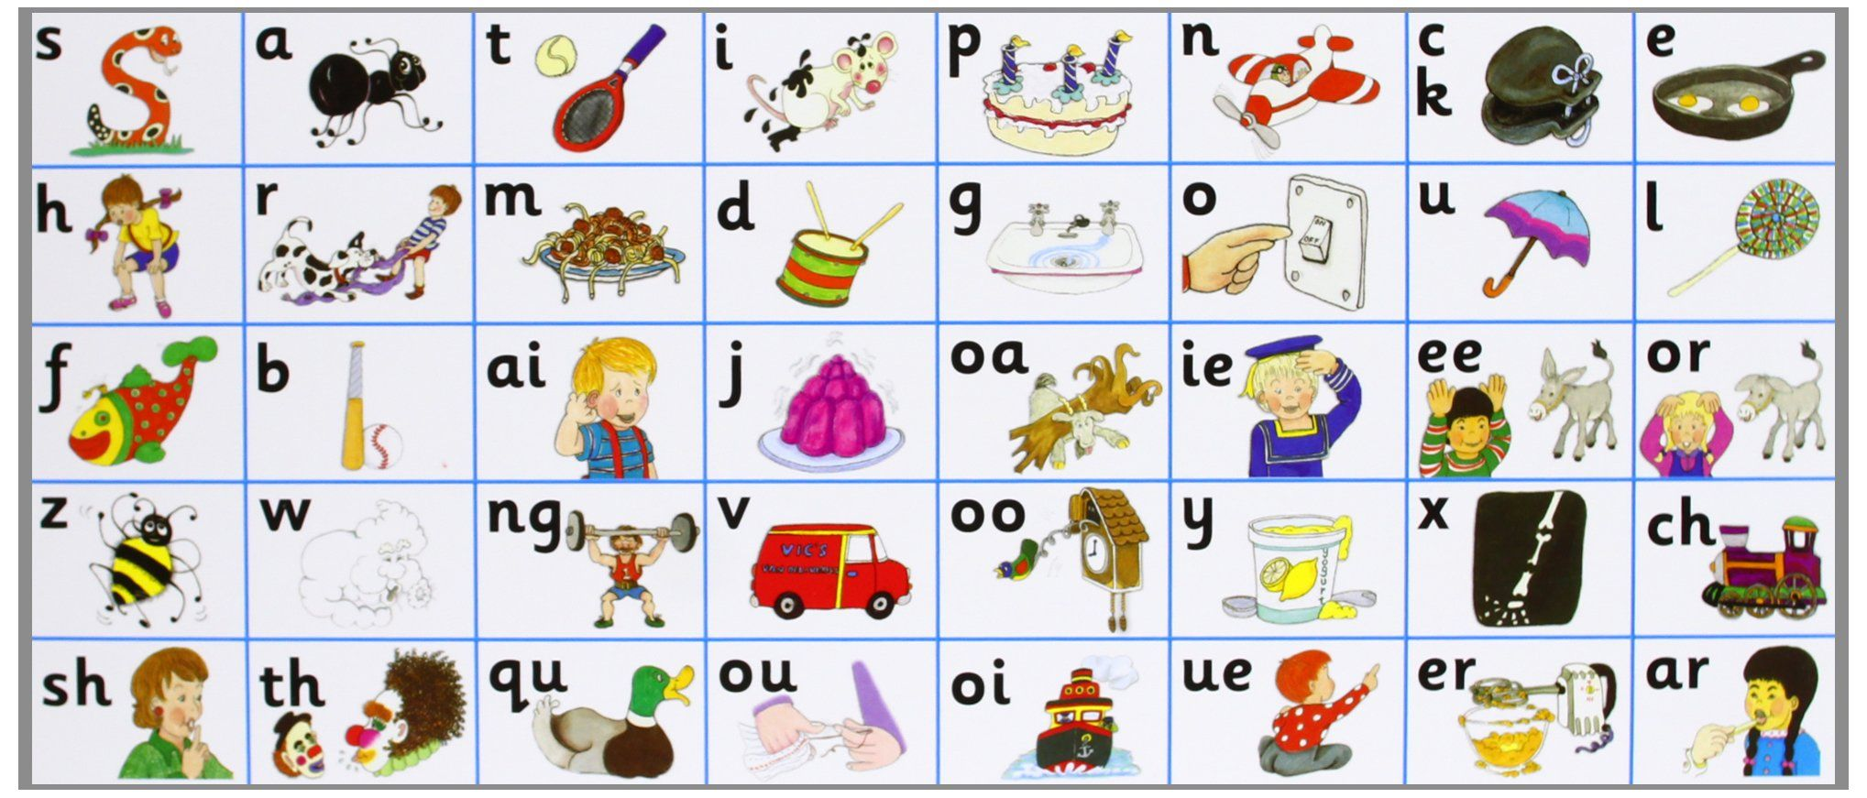


Don’t forget your finger spaces!
separate extra information in a sentence
shows exclamations, commands, or strong emotions
used to join words or add a prefix

shows direct speech
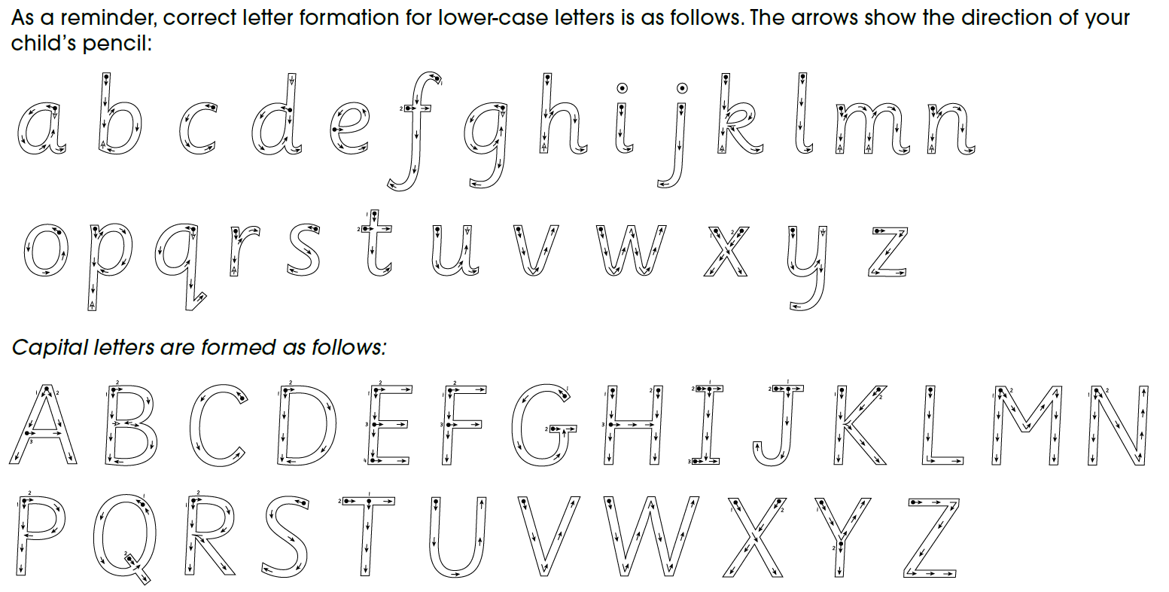
used to join clauses and separate long lists
adds tension by creating a pause

