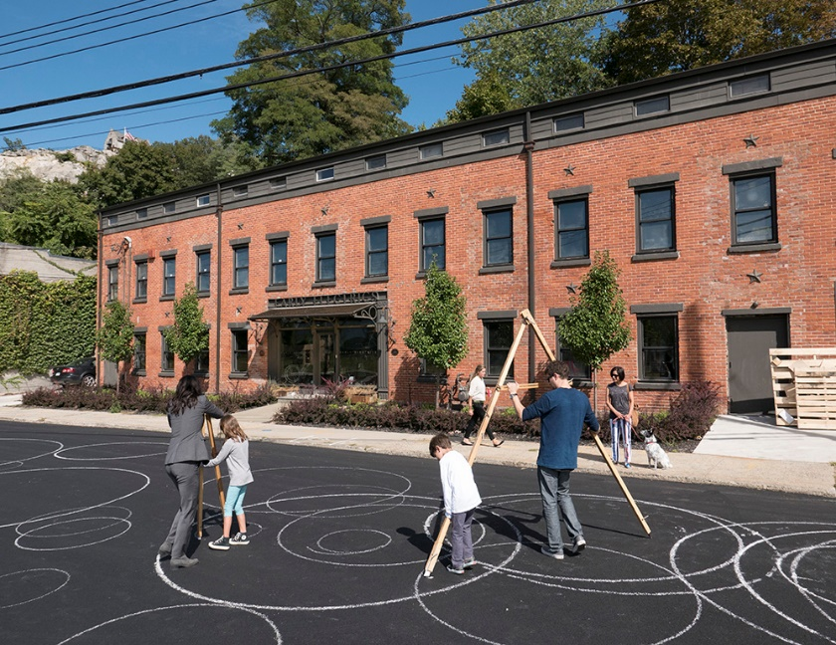
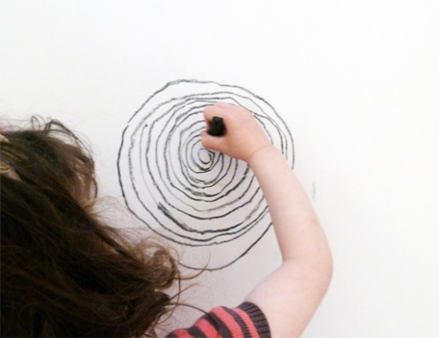
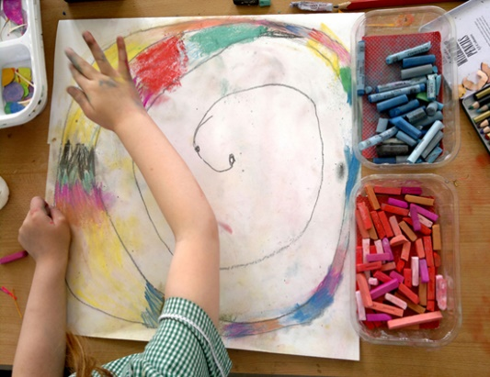
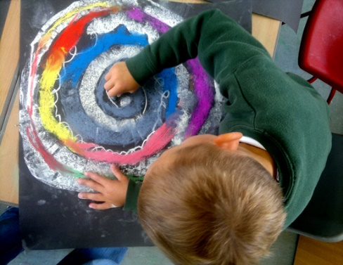
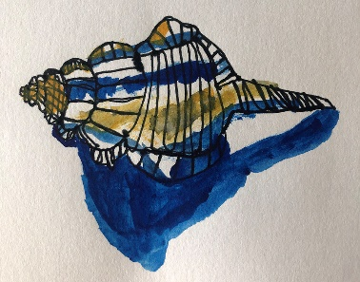
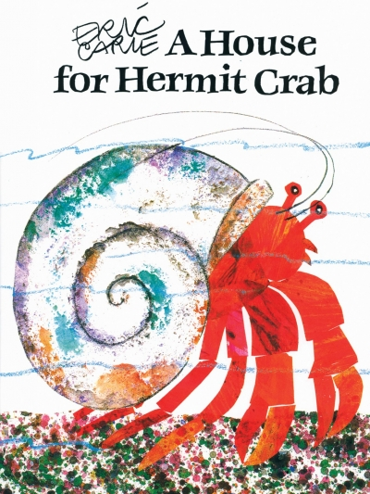
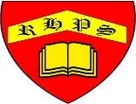

Mollie Haslund is an artist who makes drawings outside using her body as a drawing tool.

Henri Matisse created this artwork in 1953
by cutting and tearing shapes from paper.
Can you see the spiral shape of the snail’s shell?

Have you read this book by Eric Carle about a crab who has outgrown his old shell and sets out to find a new one?
Use your body to create spirals
Use different colours
Look what you will be able to do…
Use lots of different tools
Draw what you see carefully
Working together to be the best that we can be
Art – Drawing and Sketching - SPIRALS
Autumn 1
Year 1
Golden Thread: Sustainability

