
Golden Thread:
PSHE – Me and My Relationships
Autumn 1
Year 1
Working together to be the best that we can be
Feelings and emotions |  | Rules
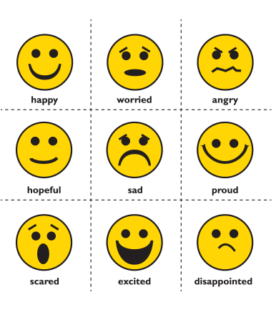 | We experience lots of different feelings. Others can tell how we are feeling from our facial expressions and body language.  We may have different feelings in different places, e.g. school, home, the park.  We can feel things in our bodies and minds.  We can talk about our feelings with people we trust. | We have rules in place to help keep things and everyone safe.  Think about the rules that we have at school, and those that you have at home. Think about how they help keep you safe.  
Key words:
Emotions – Strong feelings that affect how we behave.
Similarities –a feature or aspect we have that is the same as other people.
Differences – a way in which people are different or not the same.
Friendship – When you are friends with someone.
Relationships – the way in way two or more people are connected.
Conflict – a serious disagreement or argument.

Healthy Relationships
Relationships are the connections we have with other people (or animals).
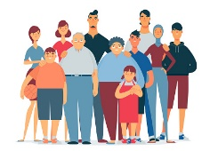  Special People  Special people are the people that are important in our lives.  Special people help us or take care of us. We don’t always get along with the special people in our lives, but the doesn’t mean that we done still care for each other. | 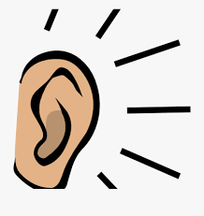  Listening  Listening is important to help us build good friendships.  We should listen carefully to each other, not just each-others words, but also others behaviours.

