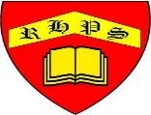
Year 2
Geography – Unit 1 – Land and Seas (Continents and Oceans)
Golden Thread: Sustainability
Autumn 1
Working together to be the best that we can be
Talking Points
How many continents are there?
How many oceans are there?
What are landforms? Where can they be found and why?
How do continents differ? Why are they different?
Map of the worlds 7 continents and 5 oceans
United Kingdom countries and surrounding seas

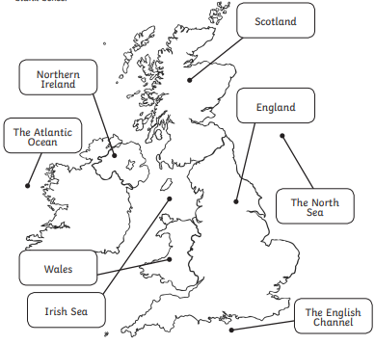
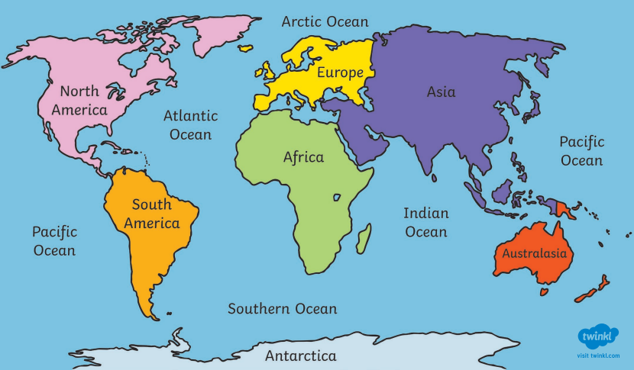

Key vocabulary
Sea - a body of salt water that sits between the land and the ocean.
Ocean - a large body of salt water that surrounds continents.
Land - a raised area of earth above the sea level.
Continent - a group of countries that are near each other
Country - an area of land that is ruled by one government.
Landform - a natural feature of the earth’s surface.

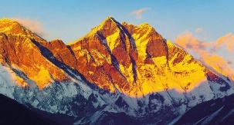
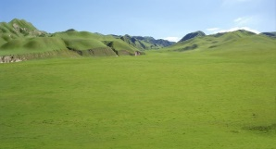

Landforms

Hills
Beaches
Mountains
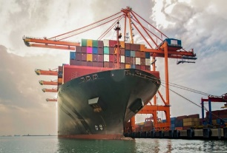
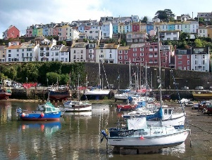
Average yearly temperature of countries around the world
Ports and harbours

Port – a large place where boats can load and off load cargo.

Harbour – Spaces where boats can rest away from the waves of the sea.

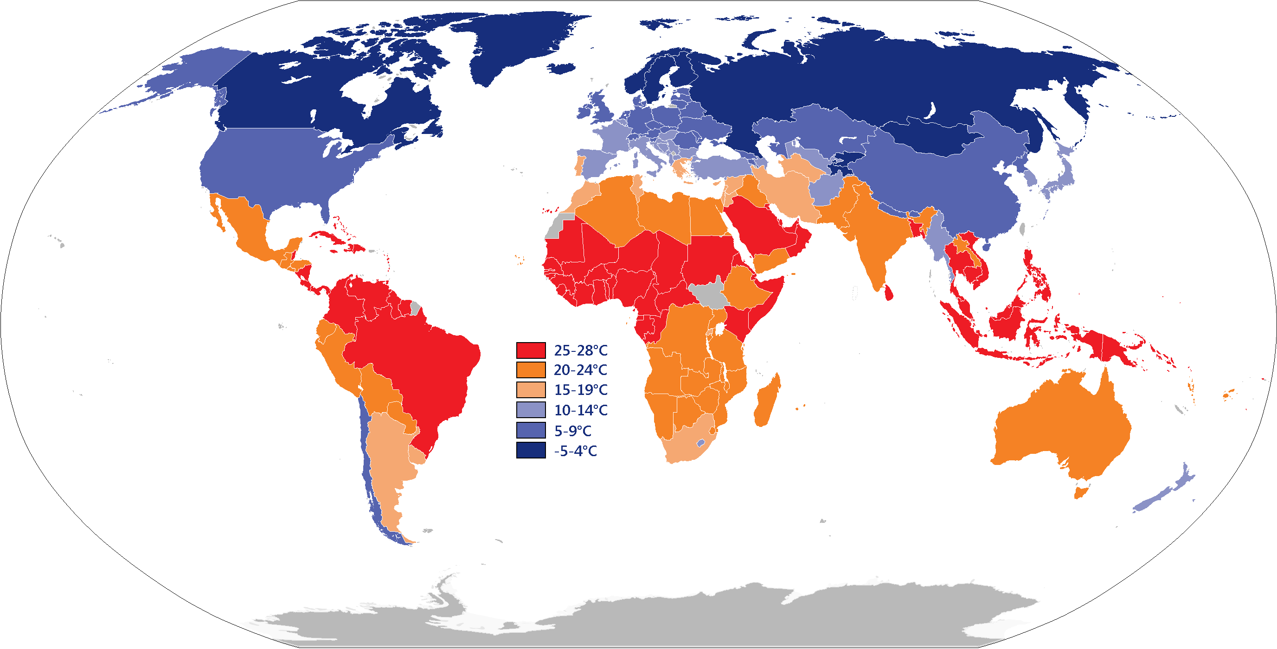

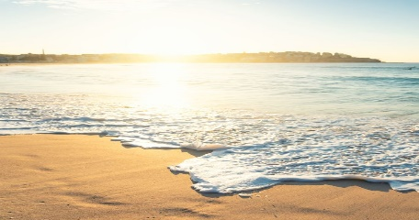
The temperatures of continents vary because of where they are in the world. How does this affect these different areas?

