
Golden Thread: Belonging
English – Unit 1: What makes a writer?
Autumn 1
Year 2
Working together to be the best that we can be
Nouns
Naming words
Proper – names and places begins with a capital letter eg. England
Abstract – thoughts or feelings eg. happiness
Concrete – things you can touch eg. table

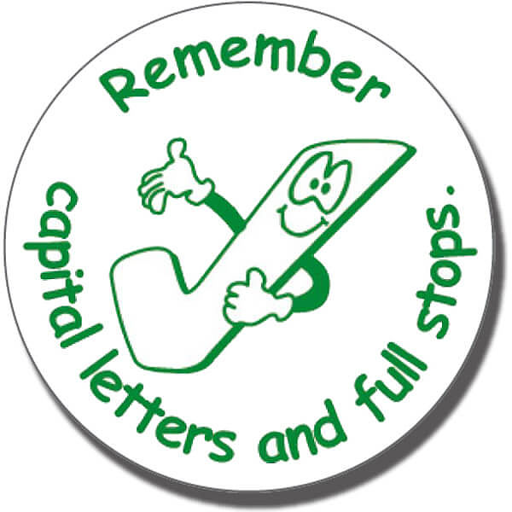
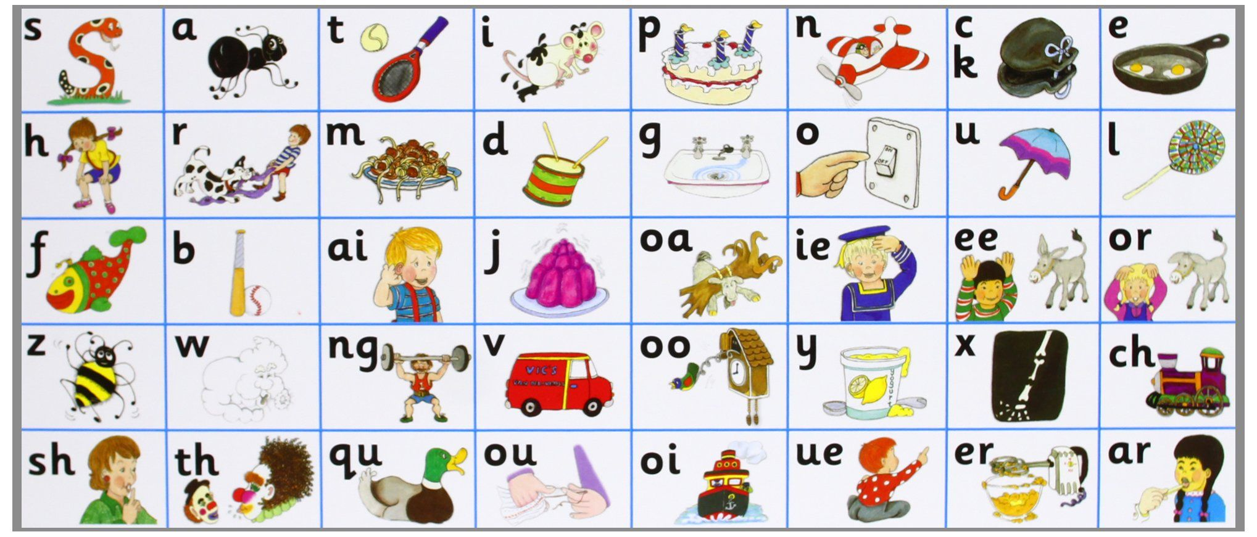

Don’t forget your finger spaces!
separate extra information in a sentence
shows exclamations, commands, or strong emotions
used to join words or add a prefix
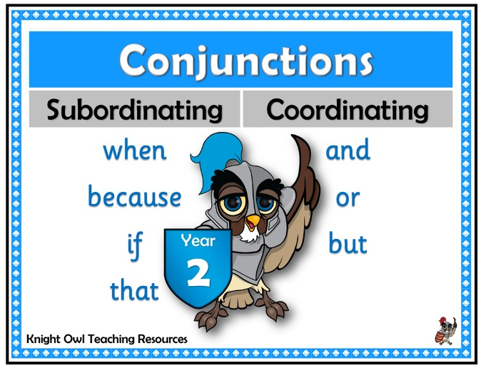
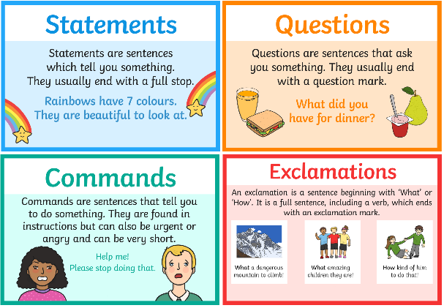

shows direct speech

used to join clauses and separate long lists
adds tension by creating a pause

