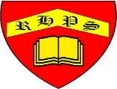
Working together to be the best that we can be
Art – Drawing and Sketching – Explore and Draw
Autumn 1
Year 2
Golden Thread: Sustainability
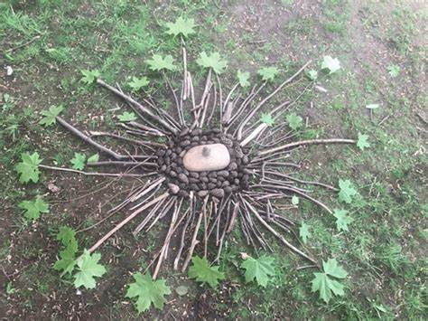
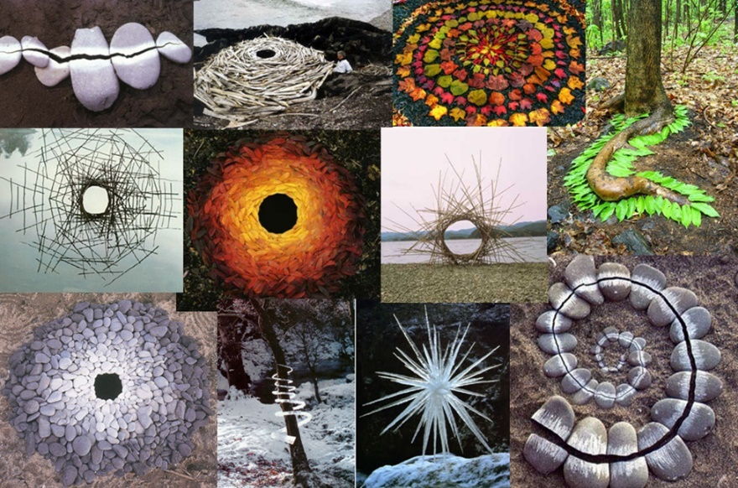
Explore
Environment
Nature
Inspiration
Collect
ReSee
Imagine
Curious
Light
Shade
Observation
Draw slowly
Pressure
Line
Mark

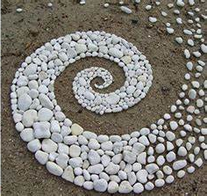

Andy Goldsworthy, was born in Cheshire on 26 July 1956 and lives and works in Scotland.
He is a British sculptor, photographer and environmentalist producing sculpture and art in natural and urban settings.

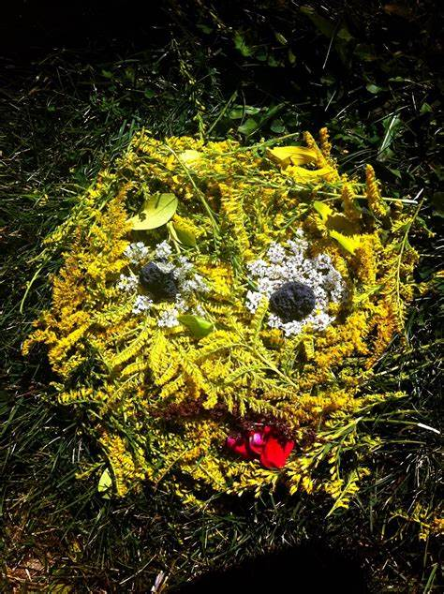
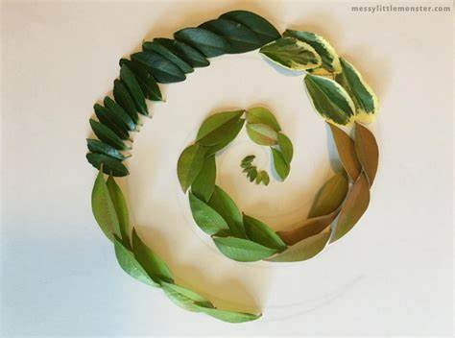
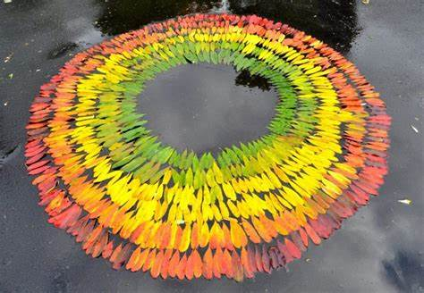
What will you create?
Which of these inspires you?

