Feelings and emotions | Feeling safe
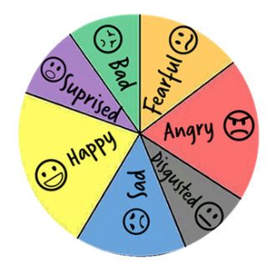  We may have different feelings in different places, e.g. school, home, the park, and this is normal.  We can discuss our feelings with people with trust, like a trust adult or friend.  Sometimes feelings make us feel good but sometimes they don’t. It is important we know who we can talk to about our feelings to help us control them a little better or get help. This can also help us support others when they are experiencing certain emotions. | We have rules in place to help keep things and everyone safe.  It is important that we all feel safe and rules can help us with this – especially at school. We all have to play a role to keep each other safe.  Democracy is important; when we create rules together we have more control over them, so we can pick the rules that we think are the most important to us.  

Golden Thread:
PSHE – Me and My Relationships
Autumn 1
Year 2
Working together to be the best that we can be
Healthy Relationships
Relationships are the connections we have with other people (or animals).
Unkindness, teasing or bullying
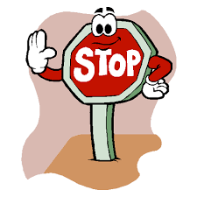
Bullying is when someone is repeatedly mean or unkind to someone. STOP – Several Times On Purpose.
This could be: saying unkind words; calling names; hitting or hurting someone; leaving people out.
Being a good friend
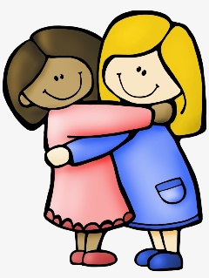
Good friends mostly do: Share their things; look after each other; are kind; notice is someone is being left out or feeling lonely
Good friends mostly don't: leave people out; stop listening to each other; ignore when people are feeling left out or lonely.

Key words:
Bullying Teasing Democracy Support Respect Emotions Relationships Friendship

