
Golden Thread: Belonging
English – Unit 1: What makes a writer?
Autumn 1
Year 3
Working together to be the best that we can be
Nouns
Naming words
Proper – names and places begins with a capital letter eg. England
Abstract – thoughts or feelings eg. happiness
Concrete – things you can touch eg. table

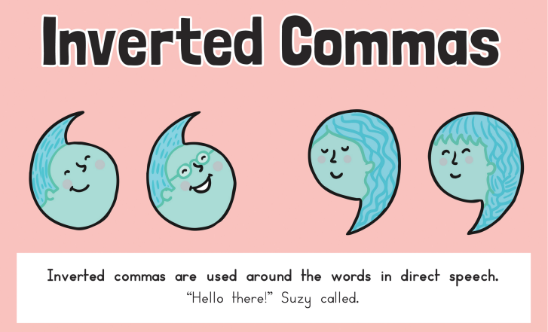
Noun Phrase
Contains a noun and modifiers about the noun eg.
The small, yellow car

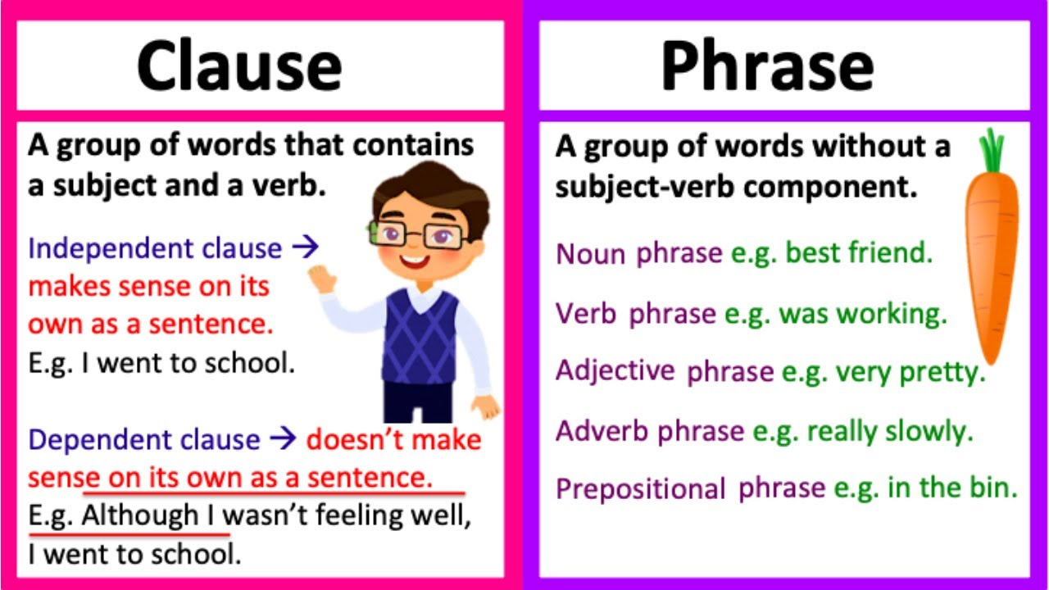

separate extra information in a sentence
Verbs – action words
Adverbs – describes the action
Adjectives – describing words

shows exclamations, commands, or strong emotions
Vowels
a e i o u
If the word after begins with a vowel, use ‘an’

used to join words or add a prefix
shows direct speech
‘ apostrophe
, commas

! exclamation
marks
“” inverted
commas

shows missing letters and possession
used in lists, to join clauses, and separate extra information

shows exclamations, commands, or strong emotions

shows direct speech

used to join clauses and separate long lists
adds tension by creating a pause
Can I identify the word classes of a simple sentence?

The young boy ran quickly to the party.
adverb

determiner
verb
noun
preposition
adjective

