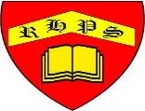
Meet Laura McKendry, an artist who uses charcoal to make gestural drawings of dogs.
Working together to be the best that we can be
Art – Drawing and Sketching – Gestural Drawing with Charcoal
Autumn 1
Year 3
Golden Thread: Civilisations
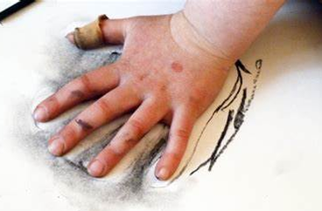
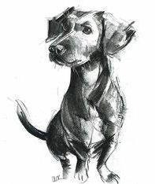
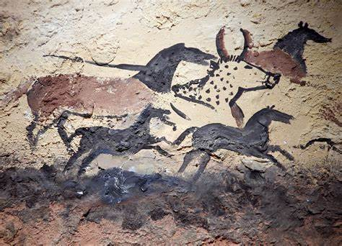
How will you use these idea to draw like a cave man?



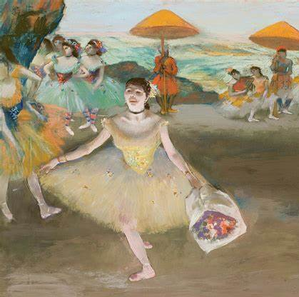
The oldest cave art is from El Castillo Cave, in Spain. There, a collection of handprints and animal drawings decorated the ceiling of a cave about 40,000 years ago.

Charcoal
Gestural
Chiaroscuro
Expressive
Atmosphere
Shadow
Lighting
Narrative
Composition
Handprints
Story telling
Tools

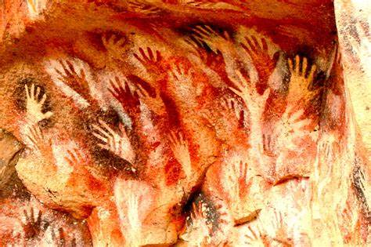
And this is by Edgar Degas who used charcoal and chalks to depict ballet dancers in France around 1875

