
Golden Thread:
PSHE – Me and My Relationships
Autumn 1
Year 3
Working together to be the best that we can be
Healthy Relationships
Relationships are the connections we have with other people (or animals).
Looking after our special people  We all have people that are special to us: parents, siblings, friends, and teachers.  These people make us happy and are there to support us. They will help us overcome challenges, show us love and affection and guide us to make the right choices. | Working together  Team work and cooperation are very important. Sometimes we have to work as a group to solve problems.  When we work with others it is important to listen to each other, respect each other’s opinion and show tolerance.
Special Friendships  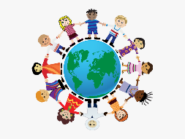  Friends are special people in our lives. It is important to have healthy friendships.  Even best friends sometimes fall out, but when that happens it is important to stay calm, apologise, listen, explain your feelings and find a solution together to resolve the conflict. | Challenges and dares  A challenge is something that cannot be completed easily. It is good to have challenges to overcome, in order to build our skills and experiences.  A dare is when someone tries to get someone to complete a challenge. Some dares can be positive but some dares can make people feel uncomfortable.  You should not feel pressured to do things just because someone else tells you to do it.

Feelings and emotions | Rules and consequences
Our inner feelings are also known as our emotions. There are many emotions that we feel each day, including: happy, sad, angry or scared.  Our emotions can often be seen through our facial expressions and our body language.  It is ok and natural to have any feelings. We can discuss how we feel with people that we trust.  The way we behave can have an impact on the emotions of others. We can use different strategies to manage these emotions and the emotions of others. 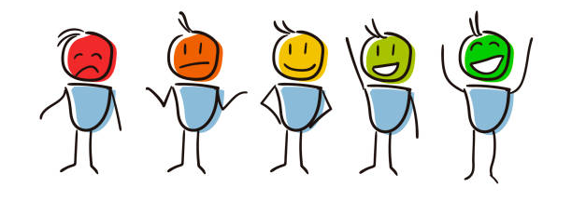 | We have rules in place to help keep things and everyone safe.  It is important that we all feel safe and rules can help us with this – especially at school. We all have to play a role to keep each other safe.  When rules are not followed correctly there may be consequences, because rules are in place for a reason.    Democracy is important; when we create rules together we have more control over them, so we can pick the rules that we think are the most important to us.

Key words:
Consequences Democracy Respect Emotions Conflict Risk Dare Challenge

