
Geography – Unit 1 – Rivers 1
Golden Thread: Sustainability
Autumn 1
Year 4
Working together to be the best that we can be
Rivers
Rivers are a flow of fresh water that run across the land and into the sea or a lake.
Talking Points
What is a river?
What are the major rivers of the world?
What is erosion, transportation, and deposition?
How do rivers shape the land around them?
Why are rivers important to people?

Parts of river
Rivers start at the source in the upper course amongst hills or
mountains. Rivers are small and shallow here.
The river then runs downhill along its channel through
the middle course. The river flows quickly and has lots
of energy.
In the lower course, the river is wide and deep and meets the sea.
Where the river meets the sea id known as the mouth.

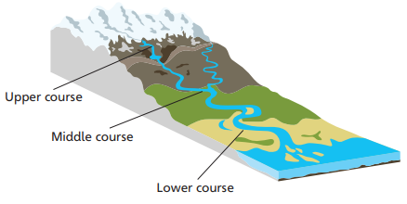

Key vocabulary
Channel - where a river flows delta A triangle-shaped area of marshy land found at the mouth of a river
Deposition - the process of material being dropped
Erosion - the process of land being worn away
Mouth - where a river joins the sea or a lake
Pollution - the process of harmful substances being released into the environment
Sediment - bits of soil and rock eroded, transported and deposited by a river
Source - where a river starts
Transportation - the process of material being carried
Waste water - Water that has been used by people, e.g. for washing clothes

Deposition
When rivers have less energy (flow slowly) they deposit sediment.
For example, on the inside of a river bend the water flows slowly and deposits sediment that it has been carrying.
A river bend:
Erosion

Attrition - when bits of rock crash together in the water and break up. Abrasion - when bits of rock in the water rub against the riverbed and river banks. Solution - when acids in the water dissolve rock.
Hydraulic action - when the power of the water breaks bits off the riverbed and banks.
Transportation

Traction - when large rocks are rolled along the riverbed.
Saltation - where bits of rock bounce and jump along the riverbed.
Suspension - when small particles of sediment are carried along in the flow of the river.
Solution - when the smallest bits of sediment are dissolved into the water and carried along.
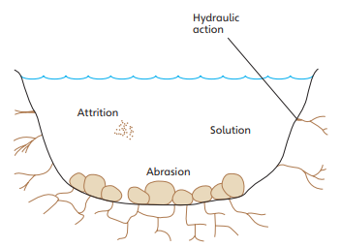
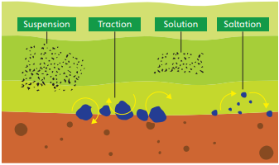

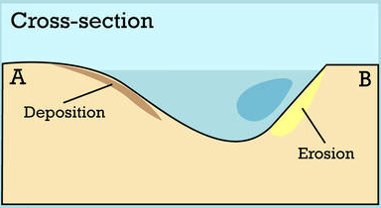
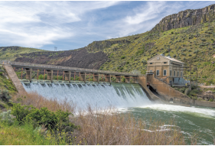
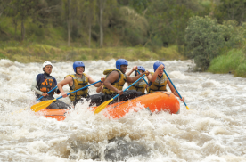
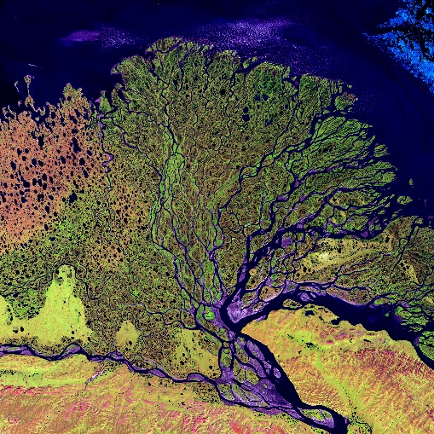
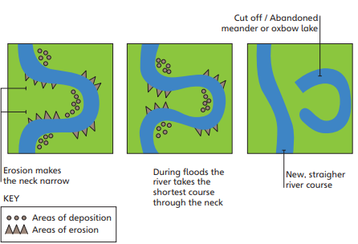
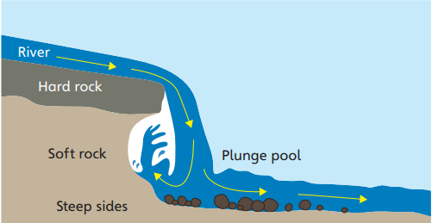
River features Deltas
Waterfalls Meander and Ox Bow lakes
Major rivers
The River Nile, Egypt.
The Amazon River, South America.
They are both over 6,000 kilometres long.

Why rivers are important to people?
- Transport
- Dams and energy
- Farming
- Leisure
- Water
- Fishing
- Businesses
- Spiritual significance
- Habitat

Golden Thread: Sustainability
Year 4
Autumn 1
Geography – Unit 1 – Rivers 2
Working together to be the best that we can be

