
Golden Thread: Belonging
English – Unit 1: What makes a writer?
Autumn 1
Year 4
Working together to be the best that we can be
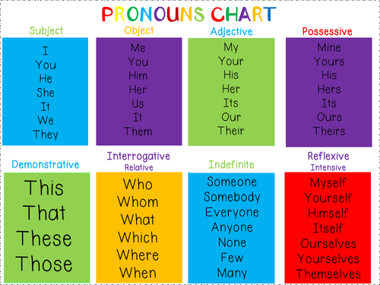
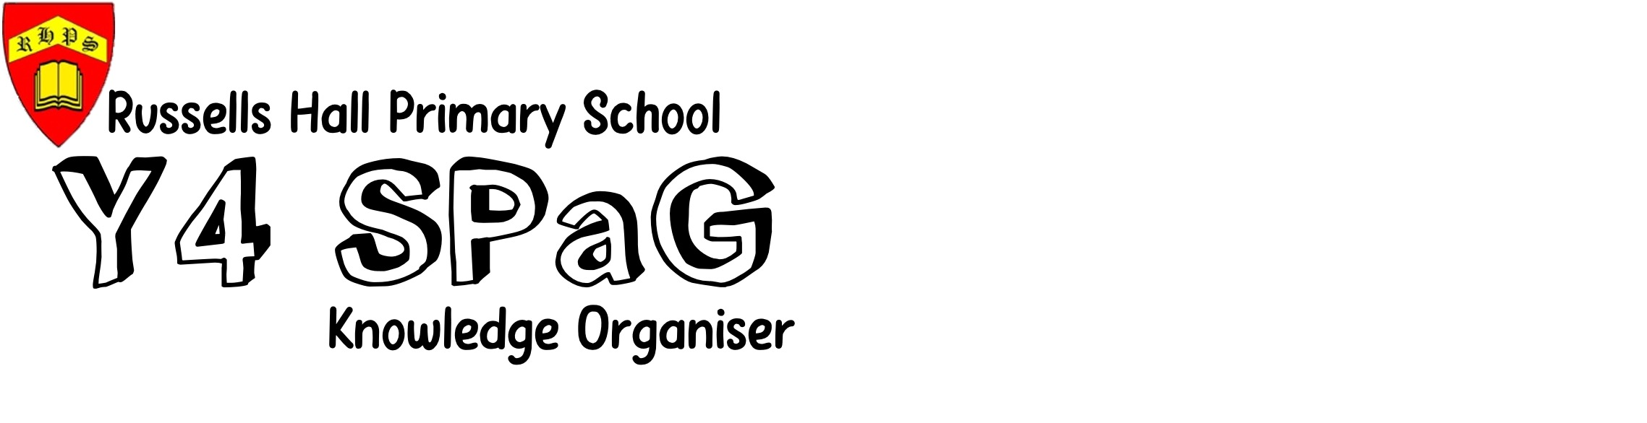

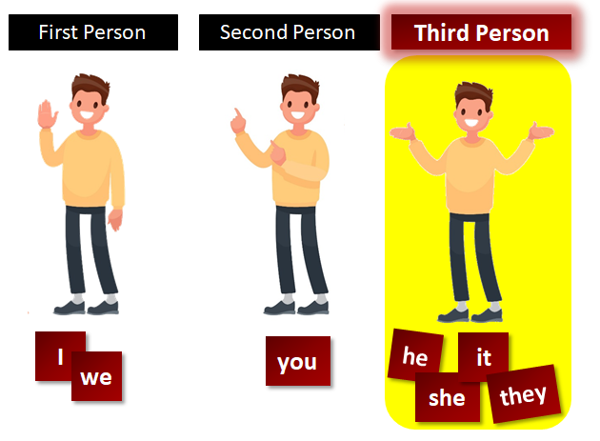
Verbs – action words
Adverbs – describes the action
Adjectives – describing words

‘ apostrophe
, commas

! exclamation
marks
“” inverted
commas

shows missing letters and possession
used in lists, to join clauses, and separate extra information

shows exclamations, commands, or strong emotions

shows direct speech

separate extra information in a sentence
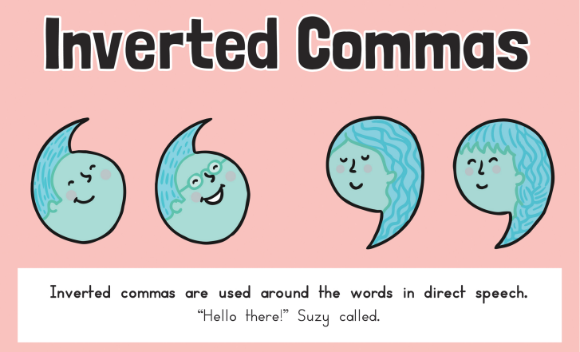
shows exclamations, commands, or strong emotions
Nouns
Naming words
Proper – names and places begins with a capital letter eg. England
Abstract – thoughts or feelings eg. happiness
Concrete – things you can touch eg. table

used to join words or add a prefix
shows direct speech
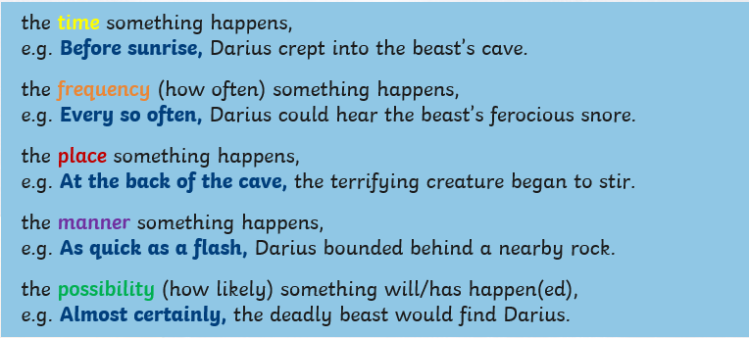
Fronted Adverbials
Fronted adverbials come at the start of a sentence. They modify a verb or clause.

used to join clauses and separate long lists
adds tension by creating a pause

Tenses

Present Perfect
Past
Future
had
will have
have, has

