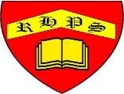
Working together to be the best that we can be
Art – Drawing and Sketching – Storytelling through Drawing
Autumn 1
Year 4
Golden Thread: Material Culture
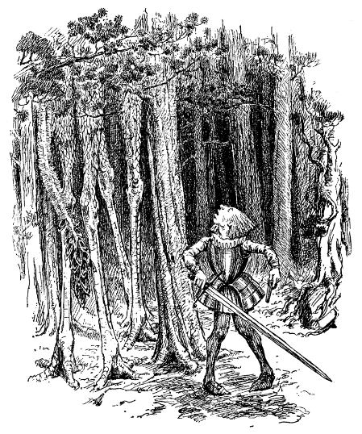
This artist illustrated part of The Jabberwocky
This is the work of Laura Carlin
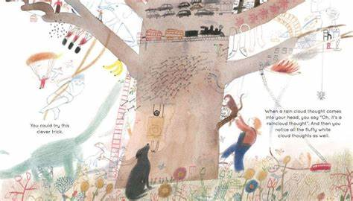

These illustrators help bring the words in books to life with their wonderful drawings

This is the work of Shaun Tan
'Twas brillig, and the slithy toves
Did gyre and gimble in the wabe;
All mimsy were the borogoves,
And the mome raths outgrabe.
"Beware the Jabberwock, my son!
The jaws that bite, the claws that catch!
Beware the Jubjub bird, and shun
The frumious Bandersnatch!"
He took his vorpal sword in hand:
Long time the manxome foe he sought--
So rested he by the Tumtum tree
And stood awhile in thought.
And of course, Quentin Blake

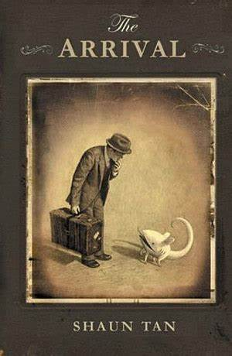
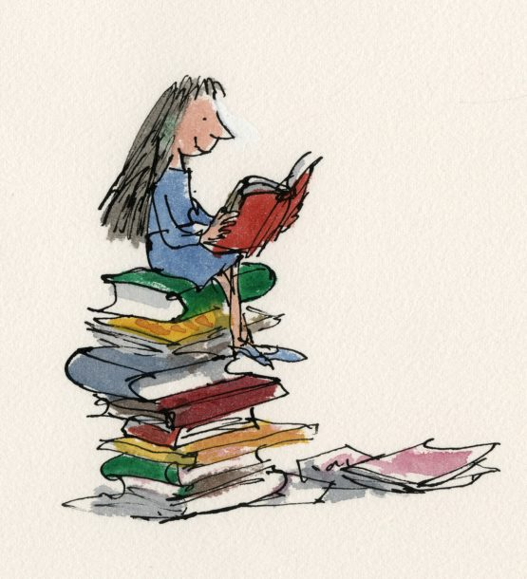
Illustration
Inspiration
Interpretation
Graphic Novel
Illustrator
Composition
Visual literacy
Narrative
Respond
Original

