
Golden Thread: Belonging
PSHE – Me and My Relationships
Autumn 1
Year 4
Working together to be the best that we can be
Healthy Relationships
Relationships are the connections we have with other people (or animals).
Its ok to say no  It is important that we all have the confidence to stand up for our own beliefs.  Sometimes we may not agree with something that someone is doing or trying to get others to do. It is okay to disagree.  Speak to an adult or person you trust if you have an internal conflict. | Working together  Team work and cooperation are very important. Sometimes we have to work as a group to solve problems.  When we work with others it is important to listen to each other, respect each other’s opinion and show tolerance.
Peer pressure  As we get older, we may feel more pressure from our friends (or others around us) to act in a certain way.  It is important to demonstrate independence and an understanding of what is right and wrong.  You should have the confidence to do the right thing and speak to someone you trust when other may be doing the wrong thing. | 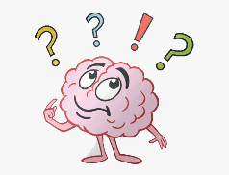  Danger and risk  A danger is a threat to someone in some way e.g. stepping into the road without looking.  A risk is when we weigh up the danger and make a decision about what to do.  When we are in a risky situation we should: 1. Stop 2. Take a breath 3. Weigh up the consequences 4. Think it through 5. Decide

Feelings and emotions | Respecting each other
There are many emotions that we feel each day, including: happy, sad, angry or scared.  Our emotions can often be seen through our facial expressions and our body language.  Sometimes we feel some emotions more strongly than others and they can also have a physical impact on us. When we experience a negative emotion we might experience flutters in our tummy or tensed muscles. A positive emotion might make us feel more relaxed or content.  The way we behave can have an impact on the emotions of others. We can use different strategies to manage these emotions and the emotions of others. | There are many ways in which we can show respect to others. These include: listening to each other; showing tolerance when someone may have a different opinion to you; accepting our differences and being polite to those around us.  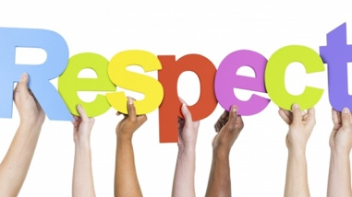  It is important that we respect all of those around us. However, we also need to respect ourselves by making the best decision for you and taking care of your own well-being.

Key words:
Consequences Cooperation Respect Peer Pressure Conflict Risk Tolerance Danger

