
Geography – Unit 1 – Slums
Golden Thread: Belonging/Social Justice
Autumn 1
Year 5
Working together to be the best that we can be
What is a slum?
The United Nations Human Settlements Programme (UN-HABITAT) says that slums are places that can’t provide basic living conditions: people don’t own their homes, there isn’t living space and water supplies are not clean or safe to drink.

Talking Points
What is a slum?
What are the similarities and differences between two slums that you have learnt about?
Where are the main slums of the world situated?
What are the living conditions like in slums?

The 5 largest slums
Orangi Town (Karachi, Pakistan) - 2.4 million
Neza (Mexico City, Mexico) - 1.2 million
Dharavi (Mumbai, India) - 1 million
Kibera (Nairobi, Kenya) - 700 thousand
Khayelitsha (Cape Town, South Africa) - 400 thousand
Who lives in slums?
Around the world, between 900 million and 1.6 billion people live in slums – it is hard to know for sure.
Slums are found in many of the world’s cities. They are where very poor people live. Slums are often overcrowded, with poor-quality housing. They usually have very bad living conditions. This means that inhabitants of slums often do not live in a safe and healthy environment.

Key vocabulary
Developers - People who make money by building houses or repairing older houses and selling them for a profit
Extreme weather - Weather that is severe and unusual, for example hurricanes or intense droughts
Landslide - Natural event when a big area of soil and/or rock slides down a steep slope
Living conditions - Things that affect the way people live, such as access to clean water, reliable electricity, and sanitation
Residents - People who live in a place permanently
Sanitation - Provision of clean water and sewage systems
Sewage - Dirty water and human waste carried away from houses in pipes and drains
Slums - Places in cities where living conditions are very poor because of lack of services and overcrowding
Working conditions - The environment that people work in: for example how safe it is, and whether there is good ventilation and good lighting

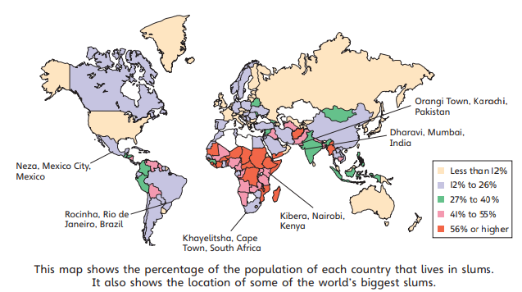
Slum locations

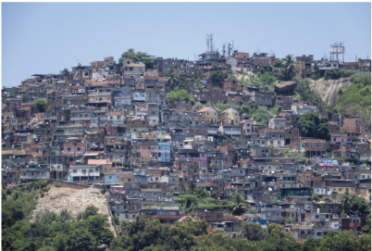

Santa Marta Favela in Rio de Janeiro, Brazil. ‘Favela’ is another word for slum.

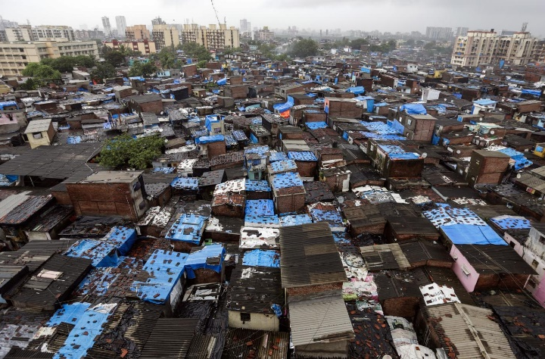
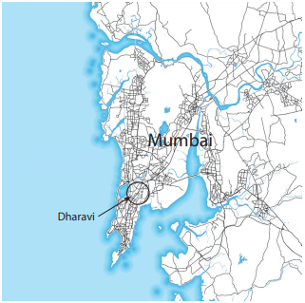
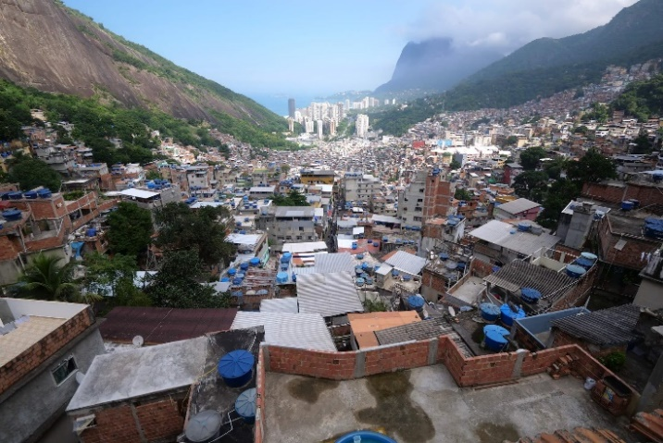
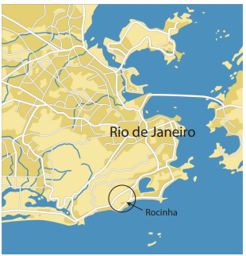
Slum development
Governments want to help improve the conditions of the lives of people who live in slums. However, there are advantages and disadvantages of improving these places.
In Dharavi, the government have built new apartment blocks. They provide people with clean water, sanitation, electricity, and string construction. However, these new apartments are far away from the city centre, there are no job opportunities and no workshop space. As a result, some people do not want to go and live in these apartments even thought he conditions are better.
Dharavi slum (Mumbai, India)
Mumbai has a population of 12 million people, and around 65% of them live in slums.
Population - Estimated: 1 million Location In a central
Location - In a central location of the city, on land that is now very valuable
Area - 2.1 km2
Famous - for Scenes from the film Slumdog Millionaire
Living conditions
- People live in crowded homes/shelters
- Limited facilities: lack of schools, few hospitals, few emergency services.
- Sanitation is a problem: people do not have toilets and there are only a few public toilets.
Economic activity
There is a great deal of economic activity in both communities. Dharavi contains workshops making pottery, jewellery, and clothes. Rocinha also plays an important role in Rio’s carnival. Tourists come to visit both slums, but they need to be careful of crime.
Rocinha favela (Rio de Janeiro, Brazil)
Rio de Janeiro is home to 6.7 million people. Over 20% of people in Rio live in favelas.
Population - Estimated: 150 thousand to 300 thousand
Location - On a steep slope in the southern part of the city
Area - Less than 2.5 km2
Famous - for Improvements to quality of life of residents, but also gangs and crime

Working together to be the best that we can be
Autumn 1
Year 5
Golden Thread: Belonging
Geography – Unit 1 – Slums

