
Golden Thread: Belonging
English – Unit 1: What makes a writer?
Autumn 1
Year 5
Working together to be the best that we can be
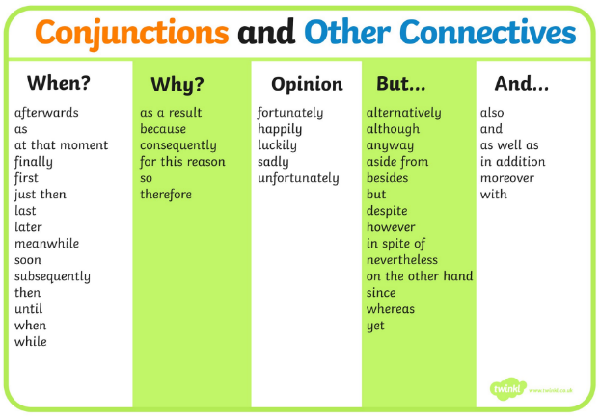


Nouns
Proper – names and places begins with a capital letter eg. England
Abstract – thoughts or feelings eg. happiness
Concrete – things you can touch eg. table
Prepositions
A words that tells you where or when something is
For example: after, before, on, under, inside, outside, behind, around

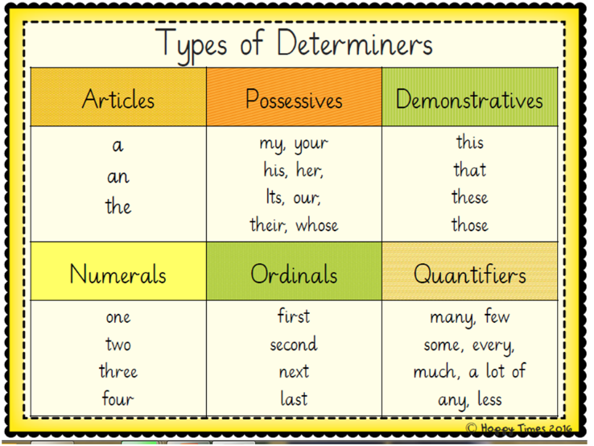
Verbs – action words
Adverbs – describes the action
Adjectives – describing words

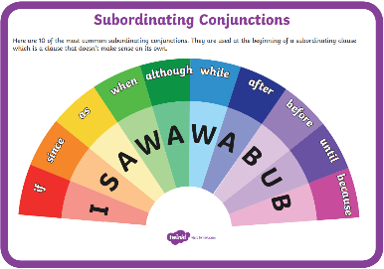
separate extra information in a sentence
shows exclamations, commands, or strong emotions
‘ apostrophe
() brackets
: colons
, commas

_ dashes
! exclamation
marks
- hyphens
“” inverted
commas
; semi-colons
… ellipsis

shows missing letters and possession
separate extra information in a sentence
used to introduce lists and join clauses
used in lists, to join clauses, and separate extra information

separate extra information in a sentence
shows exclamations, commands, or strong emotions

used to join words or add a prefix
shows direct speech
used to join clauses and separate long lists
adds tension by creating a pause

used to join words or add a prefix
shows direct speech

used to join clauses and separate long lists
Determiners either general or specific – eg. the school some children
Pronouns
Personal – represent people places and things
Possessive – what you own

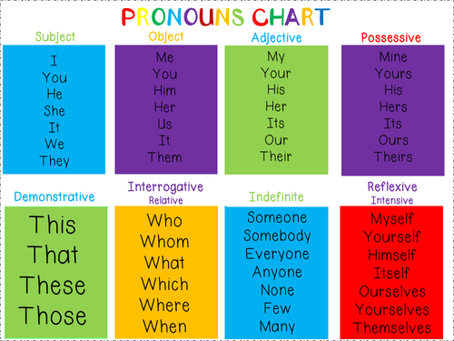
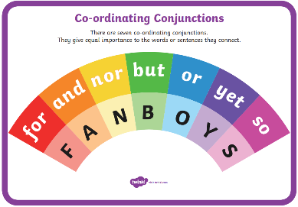
adds tension by creating a pause

