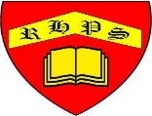
Working together to be the best that we can be
Art – Drawing and Sketching – Typography and Maps
Autumn 1
Year 5
Golden Thread: Civilisations
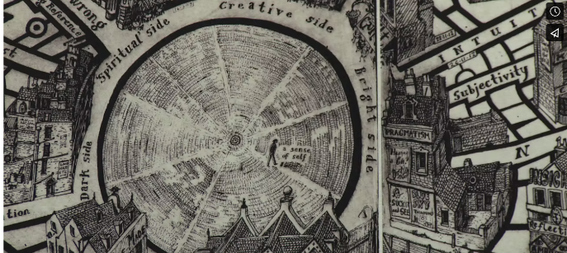
Grayson Perry was born 24 March 1960 and is an English contemporary artist, writer and broadcaster. In 2003, he was awarded the Turner Prize.
Typography
Lettering
Graphics
Design
Communicate
Emotions
Purpose
Intention
Visual impact
Pictorial Maps
Identity
Symbols
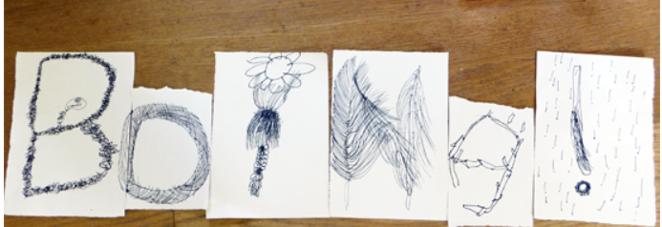
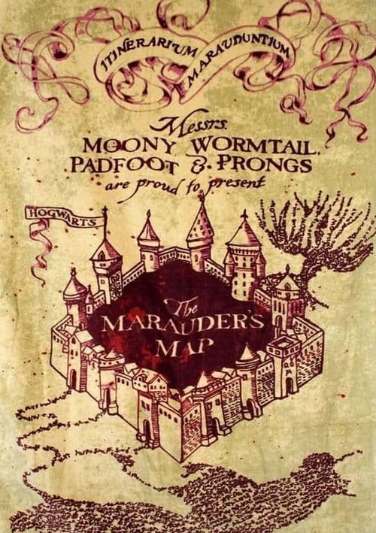
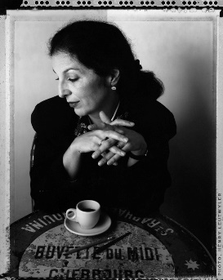
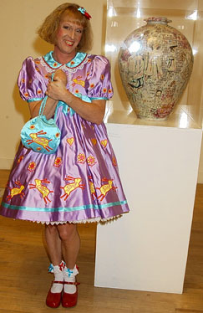
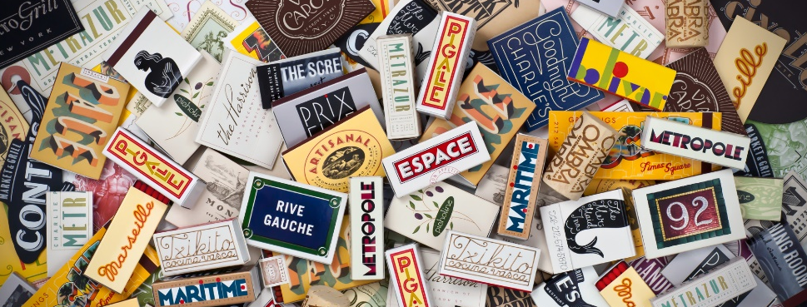
The Marauders Map featured in the Harry Potter books by JK Rowling
Louise Fili is an expert in Italian visual culture and is an internationally celebrated creative director, graphic designer, type designer, and author.
You will present and share your final pieces
You will store your ideas in your sketchbook
You will create pictorial maps
You will design typography that reflects your personality

