
Golden Thread: Belonging
PSHE – Me and My Relationships
Autumn 1
Year 5
Working together to be the best that we can be
Healthy Relationships
Relationships are the connections we have with other people (or animals).
Give and take  Friends have a responsibility to be respectful and kind to each other.  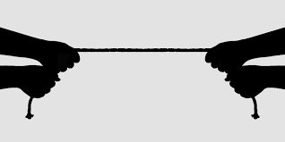  Sometimes friends to not agree with one another. When this happens, there are two strategies they can use – negotiation and compromise. | Collaboration  Often, we can complete tasks more quickly and easily when we work with others- team work is important.  A number of skills are important when collaborating, e.g. listening, communication, turn taking, negotiation and compromise.
Qualities of friendship  High quality friendships should help to make us feel happy and content. There are many different things that help us form and keep good friendships.  These include: valuing each other’s similarities and differences, helping each other meet their emotional needs, showing sensitivity and empathy towards one another, negotiating and compromising and making sure the relationship stays heathy | Being assertive  When someone is being assertive they are standing firm but still treating the other person in a respectful manner.  This is important in healthy relationships. Sometimes it is important to stand up for what you believe in, in a respectful way.
Our emotional needs | Effective communication
Emotions are the way your mind and body react to the world around you.  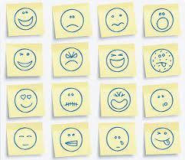  Emotions make us human. They formed through evolution to help us survive.  We all have emotional needs:  -Having caring people around us  -Having self-esteem (Feeling we are good at somethings)  -Feeling as though we are part of a group  -Trying new things  -Having some freedom (choice over the things we do)  -Spending time on our own  -Feeling safe and secure  When our emotional needs are not being met, or we do not find a solution right away, we can use some coping strategies t help us handle the situation in a positive way e.g. discussing how we feel with someone. | Communication is a very important to help us manage our emotions.  Verbal communication is one of the main way in which we can discuss our emotions, and listen to how other people are feeling.  The words we use are not the only way we can communicate how we are feeling, we can also use non-verbal communication, such as:  -Body language  -Facial expressions  -Our voices volume/tone    The way that we communicate with others can affect their emotions. The way that others communicate with us can have an impact on how we feel. How we communicate appropriately depends on our relationship with the person.

Key words:
Consequences Cooperation Respect Peer Pressure Conflict Risk Tolerance Danger

