
Geography – Unit 1 – Local Fieldwork
Golden Thread: Belonging/Sustainability
Autumn 1
Year 6
Working together to be the best that we can be
Talking Points
Why conduct fieldwork?
Why is it important to conduct fieldwork?
What tools do you need to help you to conduct fieldwork?
How can you record data that you have collected?

Why fieldwork?
Fieldwork is gathering information from a real environment, rather than from a laboratory or classroom.
Fieldwork always starts with a hypothesis or enquiry question, which is the question the geographer is trying to answer. Fieldwork then involves collecting, recording and analysing data in order to reach a conclusion.
Fieldwork allows geographers to discover and learn new things. Fieldwork also helps geographers understand more about what they have learnt in the classroom or in books.

Map
Fieldwork tools
Maps - Maps display information and data that geographers may find useful when studying a particular place
Four-figure grid references - Remember: Along the corridor (x-axis), then up the stairs (y-axis)
Field sketch - A simple drawing of the area you are studying, including labels
Survey - A review of a particular feature of the physical or human environment, for example, a traffic survey, counting number and type of vehicles
Questionnaire - A list of questions (usually with options for answers) that the researcher will ask individuals
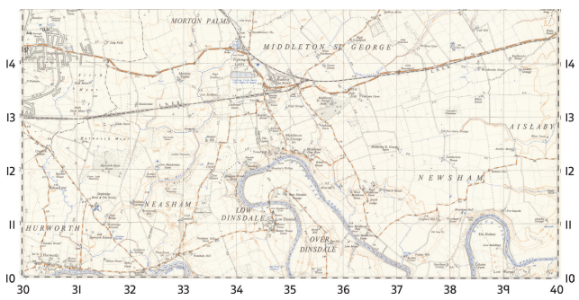
y-axis
Key vocabulary
Accuracy - How limited errors have been, therefore how likely it is that data give true results
Analysis - Detailed examination, usually of data
Conclusion - Drawing together results to reach an answer. In fieldwork, drawing results from data to answer the enquiry question
Data - Facts or information collected for analysis
Evaluation - Weighing up the positives and negatives. In fieldwork, thinking about how reliable and accurate the results are
Fieldwork - Gathering information in a real environment, outside the classroom
Hypothesis - An idea, used as the basis for fieldwork or research
Qualitative data - Data in words or images, usually containing views, opinions or feelings
Quantitative data - Data with a numerical (number) value Research - Investigation to test an idea or discover facts and information

X-axis
Compass
Field sketch
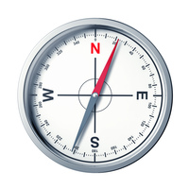
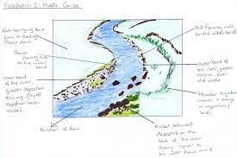

Working together to be the best that we can be
Autumn 1
Year 6
Golden Thread: Belonging
Geography – Unit 1 – Slums

