
Golden Thread: Belonging
English – Unit 1: What makes a writer?
Autumn 1
Year 6
Working together to be the best that we can be
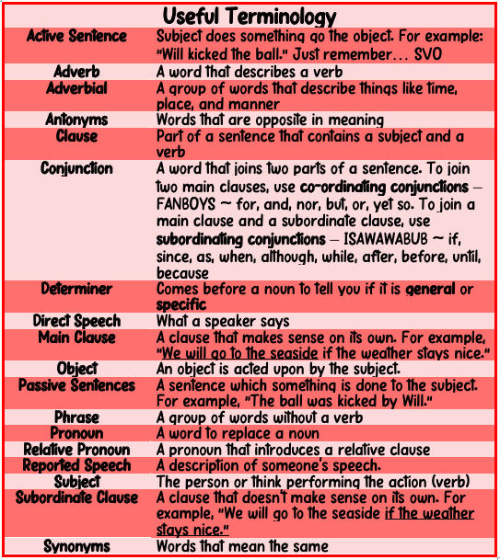
separate extra information in a sentence
shows exclamations, commands, or strong emotions
used to join words or add a prefix
shows direct speech

used to join clauses and separate long lists
adds tension by creating a pause


Prepositions
A words that tells you where or when something is
For example: after, before, on, under, inside, outside, behind, around

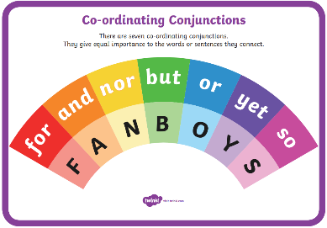
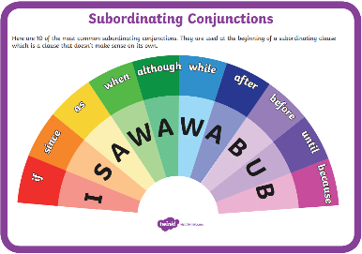
Passive and Active Voice
Active The wind broke the fence.
Passive The fence was broken by the wind.
If you can put ‘zombies’ after the verb and it makes sense, it’s probably a passive sentence!

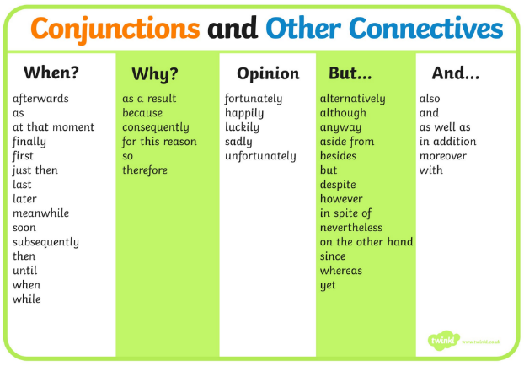
separate extra information in a sentence
shows exclamations, commands, or strong emotions
‘ apostrophe
() brackets
: colons
, commas

_ dashes
! exclamation
marks
- hyphens
“” inverted
commas
; semi-colons
… ellipsis

shows missing letters and possession
separate extra information in a sentence
used to introduce lists and join clauses
used in lists, to join clauses, and separate extra information

separate extra information in a sentence
shows exclamations, commands, or strong emotions

used to join words or add a prefix
shows direct speech
used to join clauses and separate long lists
adds tension by creating a pause

used to join words or add a prefix
shows direct speech

used to join clauses and separate long lists
adds tension by creating a pause
Verbs – action words
Adverbs – describes the action
Adjectives – describing words
Determiners – either general or specific – eg. the school
some children
Nouns
Proper – names and places begins with a capital letter eg. England
Abstract – thoughts or feelings eg. happiness
Concrete – things you can touch eg. table
Modal verbs
Show degree of certainty or possibility
Could, should, would, might, often, ought, can, definitely

