
Golden Thread: Belonging
PSHE – Me and My Relationships
Autumn 1
Year 6
Working together to be the best that we can be
Healthy Relationships
Relationships are the connections we have with other people (or animals).
Negotiation and compromise  Two strategies that can be used to maintain healthy friendships are negotiation and compromise.  Negotiation is a discussion aimed at reaching an agreement.  Compromise is reaching an agreement by people giving up something that they wanted.  These involves using skills such as listening, turn-taking and communication. | Appropriate, inappropriate or illegal  We all must understand that some actions may be deemed appropriate, inappropriate and some may even be illegal.  For example, it would be deemed appropriate to shake hands with someone when you first meet them. It would normally be inappropriate to hug a stranger. It is illegal to touch someone who does not want to be touched.
Forced marriages  Often when people love each other they want to spend the rest of their lives together. As symbol of this commitment to each other, they get married.  People should always have a choice about who it is they want to marry. It is against the law for someone to be forced into a marriage.  People may force someone to marry because: they think it is a part of their religion or culture; they think it important for reputation /honour; financial/material gain; they feel pressured by their community. | Unhealthy relationships  Maintaining healthy relationships is very important. Sometimes not all relationships are healthy, and are not good for one/more than one person involved.  In some relationships one person might pressure another or hold power over them. They may also involve physical, emotional or verbal abuse. If you feel that you have an unhealthy relationship/friendship, you should speak to a trust adult.
Our emotional needs | Being assertive
Emotions are the way your mind and body react to the world around you.    Emotions make us human. They formed through evolution to help us survive.  We all have emotional needs:  -Having caring people around us  -Having self-esteem (Feeling we are good at somethings)  -Feeling as though we are part of a group  -Trying new things  -Having some freedom (choice over the things we do)  -Spending time on our own  -Feeling safe and secure  When our emotional needs are not being met, or we do not find a solution right away, we can use some coping strategies to help us handle the situation in a positive way e.g. discussing how we feel with someone. | When someone is being assertive they are standing firm but still treating the other person in a respectful manner.  This is important in healthy relationships. Sometimes it is important to stand up for what you believe in, in a respectful way.  Being assertive does not come naturally to everyone. Some people are positive and try to avoid confrontation and do not speak up for themselves. Some people may be too aggressive, giving their opinion or point of view in a way that is too forceful.  To be assertive – stand firm, speak clearly, be friendly and polite, relax, be confident, give eye contact.  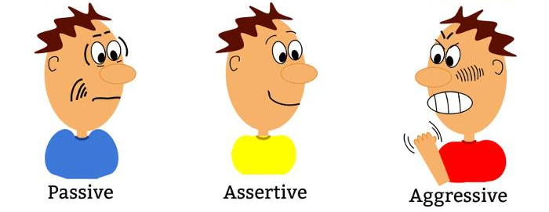

Key words:
Negotiation Compromise Marriage Appropriate Illegal Inappropriate Pressure Assertive

